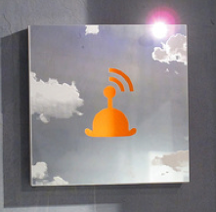

1. wi-fi magritte: the bowler is the traditional hat of bankers, clowns and cowboys. this project is about the democratization of visual art, something the other arts such as music, film and literature have already achieved. further information at blairchivers.com

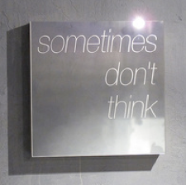

2. meditation no. 1: Each of our paintings is based on seven distinct yet inter-related concepts. Four of the seven concepts are: documenting powerful ideas, art history, fashion (art world, clothing and design) and a manifesto. more information available at blairchivers.com

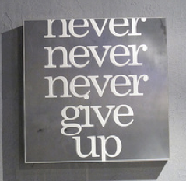

3. never give up: perseverence: Cezanne never gave up and become one of the great 20th century artists while da Vinci was notorious for not completing projects and commissions. This project is about the democratization of visual art. More clarification of the manifesto and other layers of meaning soon at blairchivers.com

